
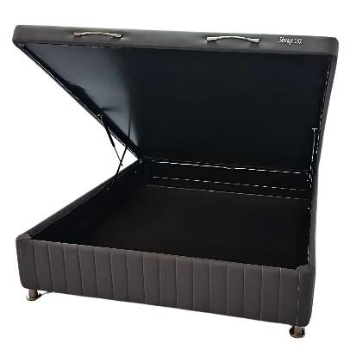
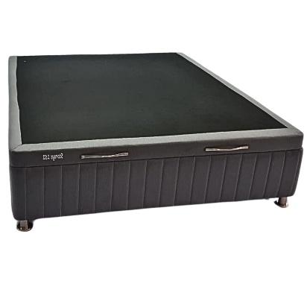

Model : Storage Base - Premier
Manufacturer : Mattress World
Features :
- Heavy Duty 7 Slat Design
- Steel Legs for Extra Support
- Luxury Textile Fabric
- 120kg Per Person Per Side
Prices Standard Length :
- Single – R2999
- Three Quarter – R3499
- Double – R3899
- Queen – R3999
- King (2 x Singles) – R5998
Prices Extra Length :
- Single – R3599
- Three Quarter – R4199
- Double – R4679
- Queen – R4799
- King (2 x Singles) – R7198

